Austin Texas Biography
Name
Institution

Austin was not always the busy city as it has been for the past decade. Many things have changed since the laying of the first cornerstone. To understand this, this paper will focus on biographical features of Austin TX especially its history, culture, climate, topography, politics, economy, and challenges facing Austin and how it is impacting the state.
Austin’s origin can be traced back to waterloo village. According to Williamson (1973) the site for the construction of city was approved by scouts and then named Austin in honor of Stephen Austin. In 1840, it had estimate of 856 residents. Two years later, the citizens defended the city from the Mexican’s invasion in the Archive War (Williamson, 1973). During this war, the residents protected and retained the records of the government even after the government relocated to Houston due to the attack. In 1845, government returned to Austin where Texas got admitted into the US. The 1839 plan of Austin as shown in figure 1.
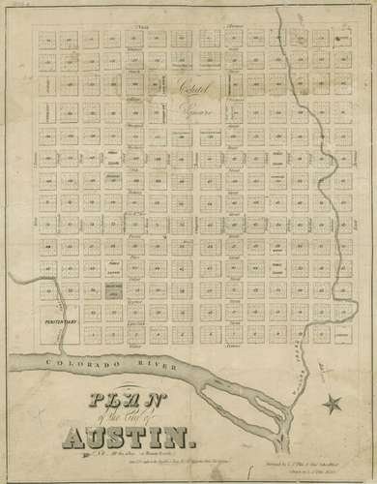
Figure 1: 1839 Plan of the Austin City of Texas
The arrival of railroad and the construction of the bridge in 1871 hastened growth of the city. It majorly promoted trade between ranchers and farmers. However, in 1900 floods caused a prevalent destruction, with collapse of the bridge (Williamson, 1973). In 20th century the river was harnessed for power and flooding could be controlled, thereby leading to industrial development. From 1990s, Austin grew dramatically due to technology and industrial growth.
Culturally, Austin is a city a center of culture and creativity. It hosts among the most known and top museums, galleries, and art centers. These cultural sites host different art exhibitions and art-related events annually. Also, Austin’s culture is friendly and accommodates other cultures. The residents are helpful and generous people, thus making the culture a liberal one. The way everyone can dress as per own preference can attest why various culture thrive within the city. In addition, Austin is sporty town, active lifestyle as well as casual dressing of the residents can verify its sporty culture. The local music also speaks a lot about Austin’s love for live music (Porcello, 2005). It is a home for many bands and when one walks around the city he or she will come across many bands that are playing. Annually, “the South-by-Southwest (SXSW) music fest and the Austin City Limits (ACL) fest where over a thousand bands participate” (Pareles, 2008). Hence, it is undeniable that Austin’s culture has shaped its reputation.
Austin’s culture was described according to Ward (2009) research as “Humid Subtropical climate”. This climate is characterized by dry winters and warm summers (Ward, 2009). However, the scientists currently have put their focus on projecting how the global climate may affect climate of various areas across the globe. One of them is Austin. Hayhoe (2014), analyzed various historical climatic changes and projected on how this global change in climate may affect Austin’s climate from 2020s to 2050s. According to Hayhoe (2014) study, the temperatures is expected to experience change while precipitation may not experience any change by 2050s. Hence, these climatic changes calls for necessary environmental action in Austin to ensure steady climatic condition in the future.
Austin’s elevation ranges from 425 feet to about 1000 feet (figure 2). Much of the eastern section of Austin city is flat as it crosses the Balcones Fault. In addition the eastern side has heavy loam and clay soils, while the western section including the western outskirts has rolling hills as it touches the verge of the Texas Hill Country. Also, due to the existence of limestone rock with a thin covering of topsoil in the hills located to the west side of the city, some parts normally experience flash floods from the thunderstorms’ runoff. As a result, there are various dams that help in controlling runoff problem and generating power. These series of dams form the Texas Highland Lakes and they are useful in various recreational activities like boating and swimming in the parks located on the shorelines.
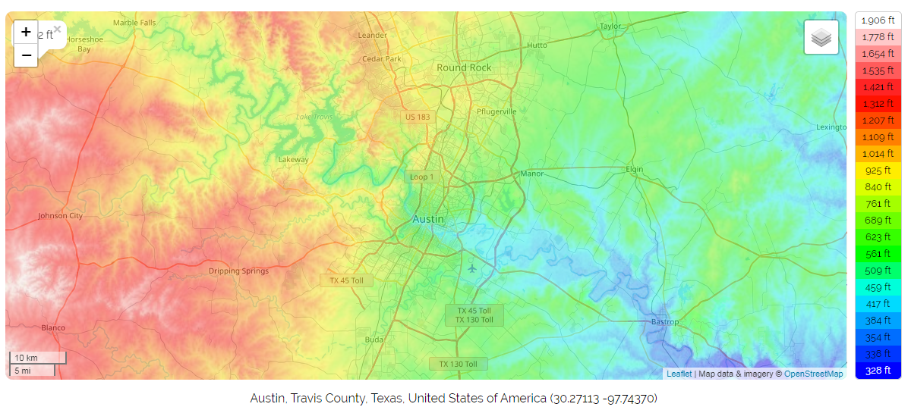
Figure 2
Politically, Austin’s political condition is moderately liberal. According to Webb (2018), Austin was the 14th most liberal areas in the US in 2018. Also, Austin city has always been among the top ten liberal cities in the US (Tausanovitch & Warshaw, 2014). In 2018, Frank Ward who was the only conservative in District 8 political race was defeated by Ellis Paige. His defeat signified a liberal monopoly that exists in Austin (Figure 3). So, there are many instances that indicates Austin’s liberal political climate and it all originates from Civil War era up to date.
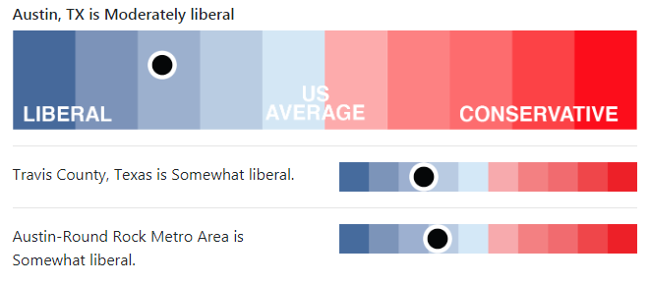
Figure 3
Economically, Austin is doing well. According to Dallas Fed (2019) Austin’s economy grew consistently from April 2019. The job growth was sharp due to increased financial activities, mining as well as construction while the number of retail jobs declined (Dallas Fed, 2019). The population growth slowed from 2017 through 2018 (Dallas Fed, 2019). The Chat 1 shows increase in growth rate to 7.4%, which was above the long-term growth rate of 6%.
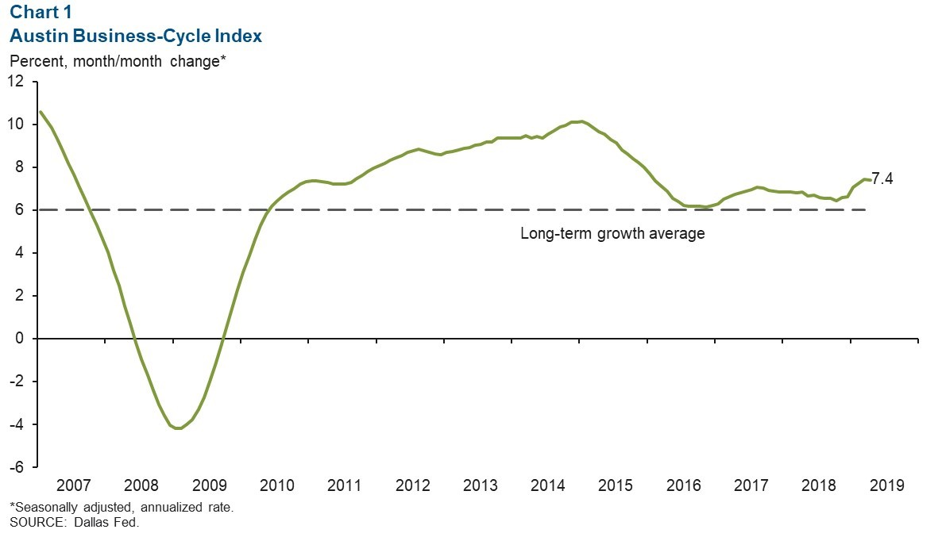
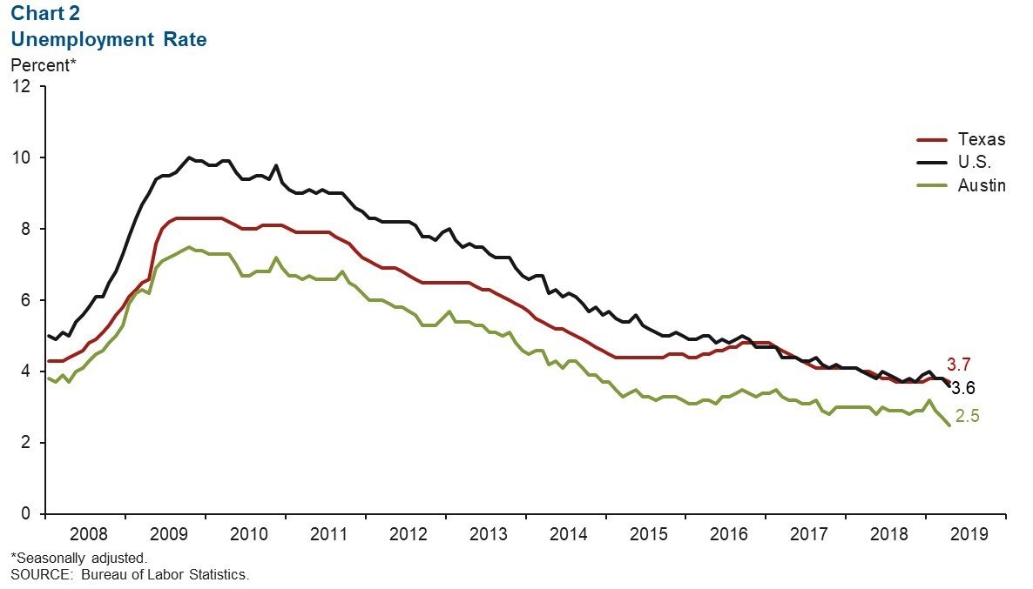
The unemployment growth rate decreased from 2.7% to 2.5% in April 2019 (Chart 2). It indicated an increase in employment opportunities.
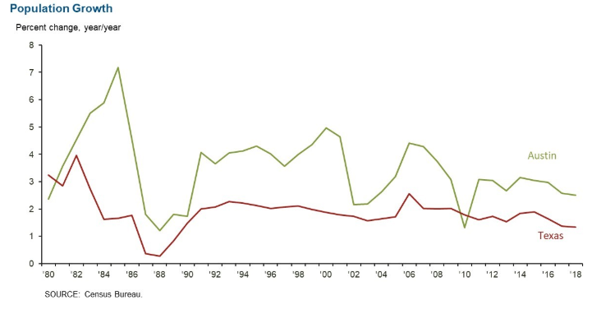
Figure 4
Also, figure 4 shows population growth rate in Austin was 2.5%, which was considerably lower to the 2017 growth of 2.6%.
Although Austin’s economy has been growing for the past years it is facing big city problems. Austin has been a leading areas that promotes business and technological progress in the entire state. Economic progress of the state has also been spearheaded by Austin city host most of the top performing tech companies like Apple and Amazon. However, one of the key problem in Austin is homelessness problem. Although multifamily housing went up in Austin this year, there has been a loss of affordable housing making most people to relocate to Houston (Cuddy, 2019). According to Garnham (2019), homelessness continues to decrease in Houston while it goes up in Austin because the cost of housing is cheaper in Houston and the cost of living is 13% cheaper as compared to Austin. Thus, the homelessness is declining, which is impacting housing sector in Houston.
Thus, Austin needs to find ways of addressing homelessness. One way it can achieve this is putting measures in place to increase the number of affordable units for the low-income earners, and the new workforce who are important in the tech sector.

References
Cuddy, J. (2019). The affordable housing crisis in Austin: how we got here, what it means, and what we need to do (Doctoral dissertation).
Dallas Fed. (2019). Austin economic indicators. Retrieved from: https://www.dallasfed.org/research/indicators/aus/2019/~/media/Documents/research/indicators/aus/2019/aus1906.pdf
Garnham, J. (2019). Why homelessness is going down in Houston but up in Dallas. Homelessness in Texas. The Texas Tribune. Retrieved from: https://www.texastribune.org/2019/07/02/why-homelessness-going-down-houston-dallas/
Hayhoe, K. (2014). Climate change projections for the City of Austin. Draft Report (ATMOS Research and Consulting, Lubbock, TX), 1-9.
Pareles, J. (2008). 1,700 Bands, Rocking as the CD Industry Reels,”. NY Times.
Porcello, T. (2005). Music mediated as live in Austin: sound, technology, and recording practice. Wired for sound: Engineering and technologies in sonic cultures, 103, 117.
Tausanovitch, C., & Warshaw, C. (2014). Representation in municipal government. American Political Science Review, 108(3), 605-641.
Ward, N. (2009). Austin climate data.
Webb, E. (2018). How liberal is Austin? Statesman News.
Williamson, R. (1973). Austin, Texas: An American Architectural History. Trinity University Press.

